**IT2120- Probability and Statistics**Lab Sheet 7

IT24102188

Thathsarani P.H.H

**Exercise**

1)



2)

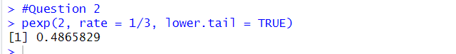

3)

1. 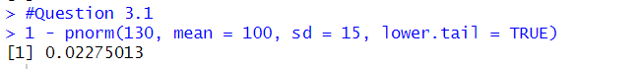
2. 